**Making an SDK release – updated 7/14/2016**

1. Create the ‘sdk-release’ folder:

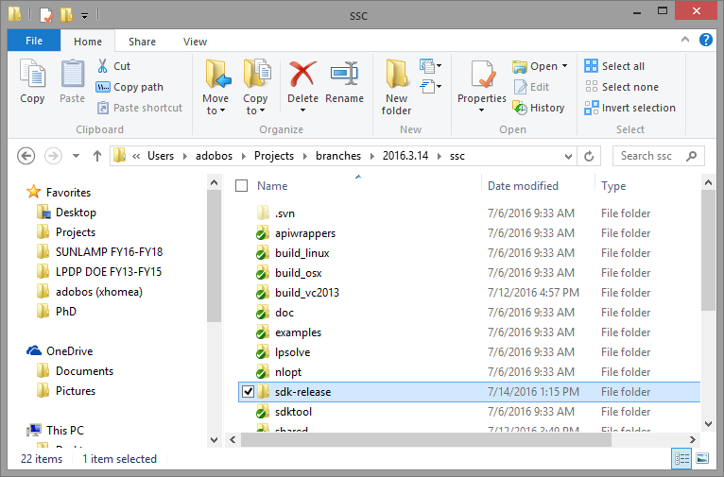

1. Check out <https://efmsvn2.nrel.gov/ssc/svn/sdk-release> into that folder
2. Open **ssc/doc/ssc_guide.tex** and recompile the **ssc_guide.pdf** using LaTeX.
3. On Windows, run ‘make-sdk-common.bat’ to update all of the api wrapper files and examples:

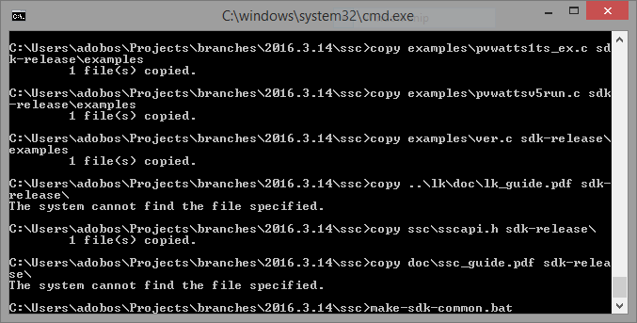

1. On all platforms, run the copy script that updates all the binaries for each platform:
   1. Linux: **./make-sdk-linux.sh**
   2. Windows: **make-sdk-win.bat**
   3. OSX: **./make-sdk-osx.sh**
2. Check in changes to the ‘**sdk-release**’ folder
3. Update the SVN on Windows to get the latest binaries for OSX and Linux
4. Select everything in sdk-release and add to a zip file:

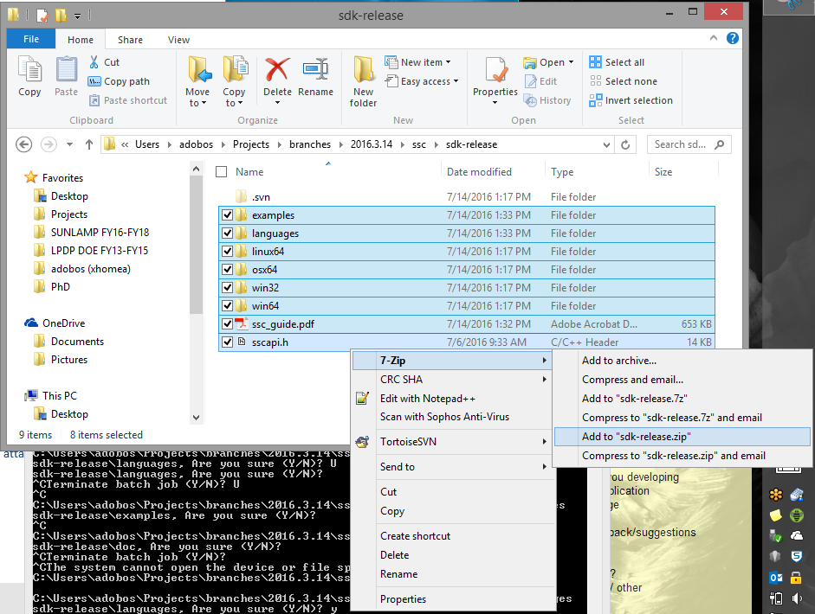

1. Rename file to **sam-sdk-2016-3-14-r2.zip** or whatever the version/revision number is for the release and post online in the right places.